Image | 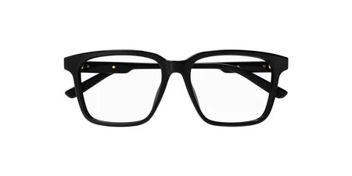
Brand | GUCCI
Model Name | GG 1293OA
Price | RS 2000
PRODUCT DETAILS

